Name: Farwa Ahmad

Roll number: MCSF19M024

Subject: Mobile Computing Week 5

GitHub link of Week 5 Applications: [MC_Progress/05WeekApplications/ListView_Adapters at master · farwa-ahmad/MC_Progress (github.com)](https://github.com/farwa-ahmad/MC_Progress/tree/master/05WeekApplications/ListView_Adapters)

Lecture 8 – Adapters

1. Added ListView, edit TextView and a Button on MainActivity

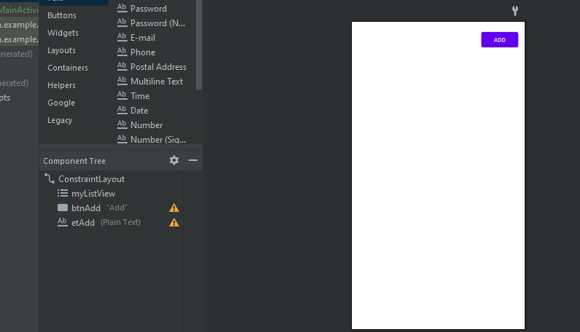

1. Added a TextView on MainActivity2

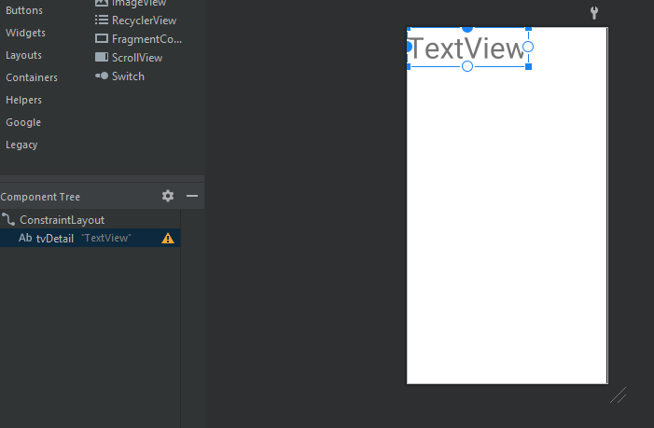

1. Renamed view IDs for easy identification
2. MainActivity Code:

package com.example.listview_adapter;  
  
import androidx.appcompat.app.AppCompatActivity;  
  
import android.content.Intent;  
import android.os.Bundle;  
import android.util.Log;  
import android.view.View;  
import android.widget.AdapterView;  
import android.widget.ArrayAdapter;  
import android.widget.Button;  
import android.widget.EditText;  
import android.widget.ListView;  
  
import java.util.ArrayList;  
import java.util.Collections;  
  
public class MainActivity extends AppCompatActivity {  
  
 Button btnAdd;  
 EditText etAdd;  
  
 @Override  
 protected void onCreate(Bundle savedInstanceState) {  
 super.onCreate(savedInstanceState);  
 setContentView(R.layout.*activity_main*);  
  
 ListView listView = findViewById(R.id.*myListView*);  
 //String [] friendList = {"Farwa","Hannia","Bakhtawar"};  
 ArrayList<String> friendArrayList = new ArrayList<String>();  
 friendArrayList.add("Sarah");  
 friendArrayList.add("Namjoon");  
 friendArrayList.add("Jungkook");  
 friendArrayList.add("Taehyung");  
 friendArrayList.add("Yoongi");  
  
 btnAdd = findViewById(R.id.*btnAdd*);  
 etAdd = findViewById(R.id.*etAdd*);  
  
 ArrayAdapter<String> arrayAdapter = new ArrayAdapter<String>(this,android.R.layout.*simple_list_item_1*,friendArrayList);  
 listView.setAdapter(arrayAdapter);  
  
 btnAdd.setOnClickListener(new View.OnClickListener() {  
 @Override  
 public void onClick(View v) {  
 friendArrayList.add(etAdd.getText().toString());  
 listView.setAdapter(arrayAdapter); //or arrayAdaptor.notifyDataSetChanged();  
 Collections.*sort*(friendArrayList); //to sort array data  
 }  
 });  
  
 listView.setOnItemClickListener(new AdapterView.OnItemClickListener() {  
 @Override  
 public void onItemClick(AdapterView<?> parent, View view, int position, long id) {  
 Log.*d*("You clicked",friendArrayList.get(position));  
 Intent intent = new Intent(MainActivity.this, MainActivity2.class);  
 intent.putExtra("Friend Name", friendArrayList.get(position));  
 startActivity(intent);  
 }  
 });  
 }  
}

1. MainActivity2 Code:

package com.example.listview_adapter;  
  
import androidx.appcompat.app.AppCompatActivity;  
  
import android.content.Intent;  
import android.os.Bundle;  
import android.widget.TextView;  
  
public class MainActivity2 extends AppCompatActivity {  
 TextView tvDetail;  
 Intent intent;  
 @Override  
 protected void onCreate(Bundle savedInstanceState) {  
 super.onCreate(savedInstanceState);  
 setContentView(R.layout.*activity_main2*);  
  
 intent = getIntent();  
 tvDetail = findViewById(R.id.*tvDetail*);  
 tvDetail.setText(intent.getStringExtra("Friend Name"));  
 }  
}

Lecture 9 – Animations

IMAGES

1. Downloaded an image from flaticons.com

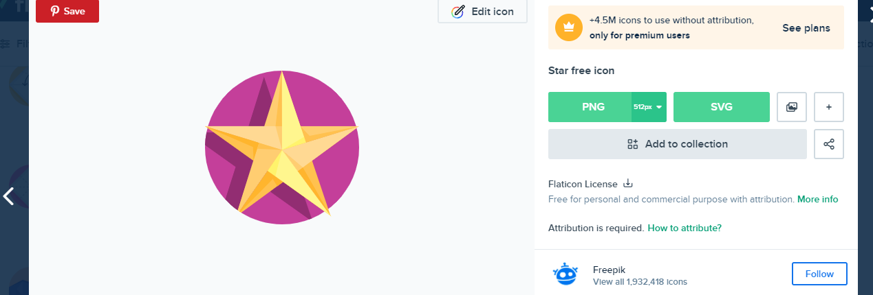

1. Copied and pasted the icon in the drawable folder of the application

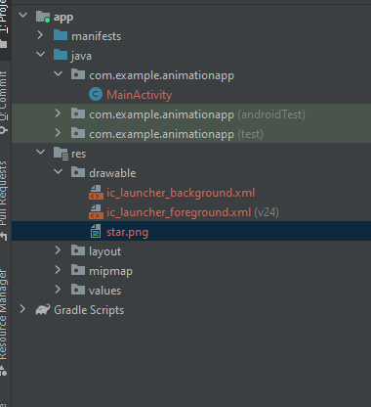

1. Used ImageView to insert the image to the activity

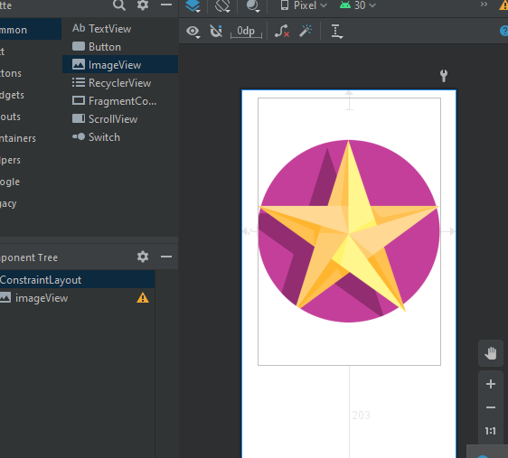

1. Wrote the following code:

ppackage com.example.animationapp;  
  
import androidx.appcompat.app.AppCompatActivity;  
  
import android.content.Intent;  
import android.os.Bundle;  
import android.view.View;  
import android.widget.ImageView;  
  
public class MainActivity extends AppCompatActivity {  
  
 ImageView ivStar;  
 @Override  
 protected void onCreate(Bundle savedInstanceState) {  
 super.onCreate(savedInstanceState);  
 setContentView(R.layout.*activity_main*);  
  
 ivStar = findViewById(R.id.*ivStar*);  
  
 ivStar.setOnClickListener(new View.OnClickListener() {  
 @Override  
 public void onClick(View v) {  
 ivStar.animate().alpha(0).translationXBy(1000).rotation(720).scaleY(0.5f).setDuration(2000);  
 Intent intent = new Intent(MainActivity.this, VideoActivity.class);  
 startActivity(intent);  
 }  
 });  
 }  
}

VIDEOS

1. Created a new Activity

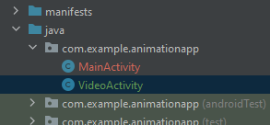

1. Add VideoView from Widgets to the layout

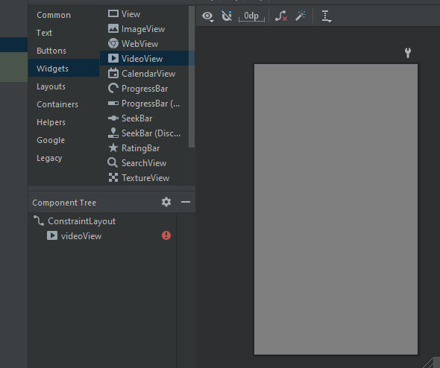

1. Created a new Android Resource Directory named raw in res folder with Resource type raw.

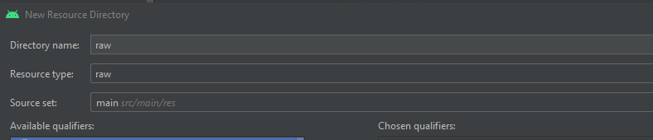

1. Copy pasted the video file in raw folder.

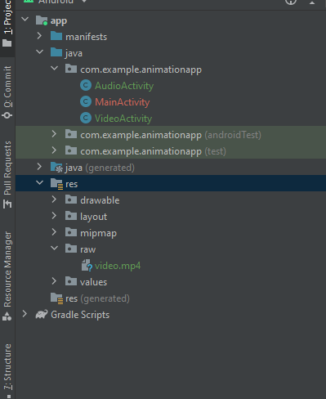

1. Wrote the following code in VideoActivity.java:

package com.example.animationapp;  
  
import androidx.appcompat.app.AppCompatActivity;  
  
import android.content.Intent;  
import android.media.MediaPlayer;  
import android.os.Bundle;  
import android.widget.MediaController;  
import android.widget.VideoView;  
  
public class VideoActivity extends AppCompatActivity {  
  
 VideoView vv;  
 @Override  
 protected void onCreate(Bundle savedInstanceState) {  
 super.onCreate(savedInstanceState);  
 setContentView(R.layout.*activity_video*);  
  
 vv = findViewById(R.id.*vv*);  
 vv.setVideoPath("android.resource://"+getPackageName()+"/"+R.raw.*video*);  
 MediaController mc = new MediaController(this);  
 mc.setAnchorView(vv);  
 vv.setMediaController(mc);  
 vv.start();  
  
 vv.setOnCompletionListener(new MediaPlayer.OnCompletionListener() {  
 @Override  
 public void onCompletion(MediaPlayer mp) {  
 Intent intent = new Intent(VideoActivity.this, AudioActivity.class);  
 startActivity(intent);  
 }  
 });  
  
 }  
}

AUDIO

1. Created a new Activity

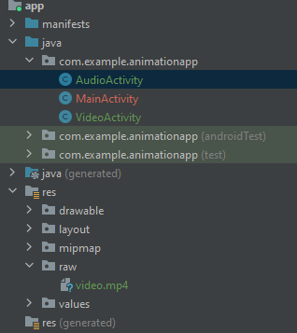

1. Copy pasted the audio file in raw folder

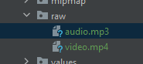

1. Designed layout

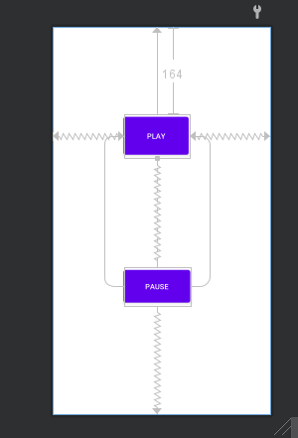

1. Wrote the following code in AudioActivity.java

package com.example.animationapp;  
  
import androidx.appcompat.app.AppCompatActivity;  
  
import android.media.MediaPlayer;  
import android.os.Bundle;  
import android.view.View;  
import android.widget.Button;  
  
public class AudioActivity extends AppCompatActivity {  
  
 Button btnPlay, btnPause;  
 MediaPlayer mp;  
  
 @Override  
 protected void onCreate(Bundle savedInstanceState) {  
 super.onCreate(savedInstanceState);  
 setContentView(R.layout.*activity_audio*);  
 mp = MediaPlayer.*create*(this, R.raw.*audio*);  
 btnPause = findViewById(R.id.*btnPause*);  
 btnPlay = findViewById(R.id.*btnPlay*);  
  
 btnPause.setOnClickListener(new View.OnClickListener() {  
 @Override  
 public void onClick(View v) {  
 mp.pause();  
 }  
 });  
  
 btnPlay.setOnClickListener(new View.OnClickListener() {  
 @Override  
 public void onClick(View v) {  
 mp.start();  
 }  
 });  
  
 }  
}